LESSON 5.

Classification, morphology and ultrastructure of spirochetes, rickettsia, chlamydia, mycoplasmas and actinomyces. Giemsa stain

LESSON PLAN:
- Classification, ultrastructure and morphology of spirochetes.
- Differentiation of treponemes, borrelia and leptospira according to morphological features.
- Features of spirochetes. Giemsa stain
- Species of spirochetes that are pathogenic to humans (genus Treponema, Borrelia and Leptospira).
- Classification, morphology and ultrastructure of rickettsiae
- Features of rickettsiae. Giemsa stain
- Types of rickettsiae that are pathogenic to humans (species Rickettsia, Orientia, Coxiella, Ehrlichia)
- Classification, morphology and ultrastructure of chlamydia
- Features of chlamydia. Giemsa stain
- Types of chlamydia that are pathogenic to humans (Chlamydia trachomatis, C.psittaci, C.pneumoniae).
- Classification, morphology and ultrastructure of mycoplasmas
- Features of mycoplasmas. The studying methods of morphology.
- The humans pathogenic mycoplasmas types (Mycoplasma and Ureaplasma species).
- Classification, morphology and ultrastructure of actinomycetes
- Features of actinomycetes. The studying methods of morphology.
- The pathogenic species of actinomycetes to humans (families Actinomycetaceae, Nocardiaceae and Streptomycetaceae).

Spirochaetaceae (spheria-curvy) are spiral-curved, curved, motile microorganisms.
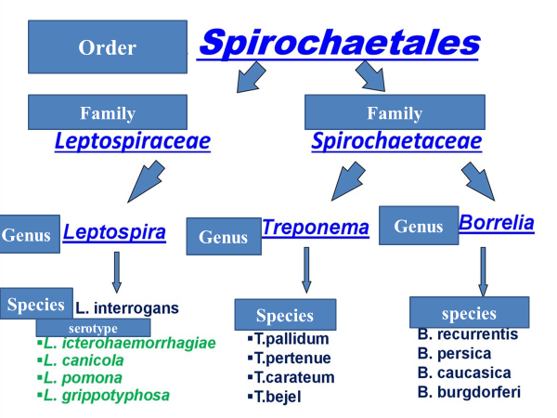
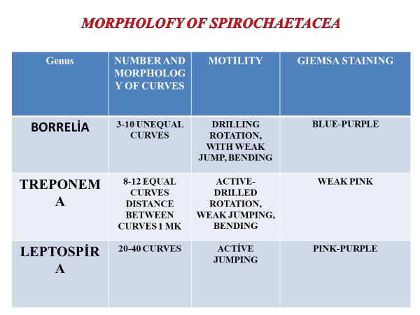

- Spirochetes are gram-negative, motile, spiral bacteria, from 3 to 500 mkm (1 mkm = 0.001 mm) long. Spirochetes are unique in that they have endocellular flagella (axial fibrils, or axial filaments), which number between 2 and more than 100 per organism, depending upon the species. Each axial fibril attaches at an opposite end and winds around the cell body, which is enclosed by an envelope.
- Spirochetes are surrounded by an outer membrane or glucose aminoglycan coating. The outer membrane is located under it and consists of peptidoglycan. Endoflagella is located in the periplasmic area and regulates the movement of spirochetes. Under the endoflagella is located cytoplasmic membrane. The cytoplasm contains nucleoids, ribosomes, mesosomes and inclusions.
- The morphology of spirochetes is studied under a light microscope in stained preparations, as well as in phase-contrast or dark-field microscopes in native (unstained) preparations.
- Borrelia well stained with aniline dyes, while others (treponema and leptospira) are difficult stained with aniline dyes, so special methods are used for them. The Giemsa method is more commonly used for this purpose.
RİCKETTSİAE
- RICKETTSIAE ARE GRAM-NEGATIVE, COCCİ-SHAPED OR ROD SHAPED PROKARYOTIC MICROORGANISMS. MOST TYPES ARE INTRACELLULAR PARASITES AND ARE NOT CULTIVATED . THEY REPRODUCE INSIDE OF THE HOST CELL BY A SIMPLE DIVISION. THUS, FOR MORPHOLOGICAL FEATURES RICKETTSIA ARE SİMİLAR TO BACTERIA, FOR BIOLOGICAL PROPERTIES (NOT CULTİVATED) IS SIMILAR TO VIRUSES. THAT IS, THEY TAKE THE PLACE OF A TRANSITION BETWEEN BACTERIA AND VIRUSES.
- Rickettsia is a genus of non-motile, Gram-negative, non-spore forming, highly pleomorphic bacteria that may occur in the forms of cocci (0.1 μm in diameter), bacilli (1–4 μm long), or threads (up to about 10 μm long).
- Rickettsiae are similar to gram-negative bacteria, consisting of a cell wall, a cytoplasmic membrane, and a cytoplasm. Bacterial cell contains nucleoides, ribosomes and mesosomes in the cytoplasm.
- Glucosamine and muraminic acids, diaminopimelic acid are detected in their cell wall
- Some rickettsia have an external membrane out of the cell wall, like gram negative bacteria.
- RICKETSIYA ARE GRAM NEGATIVE, BUT THEY ARE WEAK STAİNED WITH GRAM METHOD, WELL STAİNED WITH GİEMSA, GIMENES AND ZDRODOVSKI METHODS. LIGHT RED GRAINS APPEAR ON BLUE BACK WHEN STAİNED BY ZDRODOVSKI METHOD.
- Rickettsia is stained the by the Morozov method, in which case the rickettsiae are stained in black-brown or charcoal-black.
- RICKETS CAN BE DETECTED WITH A CONTRASTIC-PHASE MICROSCOPE IN A NATIVE PREPARATION.
- ELISA
CHLAMYDIA
- CHLAMYDIA 0.25-1.25 microns in diameter are Gram-negative prokaryotic microorganisms.
- OBLIGATES INTRACELLULAR PARASITES AND ARE NOT CULTIVATED IN MİCROBİLOGİCAL CULTURE
- ORDER CHLAMYDİALES
- PATHOGEN TYPES CAUSE DISEASES IN HUMANS, such as trachoma, ornithosis, pneumonia and s.
- Chlamydia multiply by undergoing a complex cycle of development in the host cells.
- Chlamydia may be found in the form of an elementary body and a reticulate body. The elementary body is the nonreplicating infectious particle that is released when infected cells rupture. These are sphere microorganisms with sizes 0.25-0.5 mkm
- Elementary bodies (EB) enters to the host cell and upon entry elementary bodies convert to reticular bodies (RB). which replicates within a vacuolar compartment, termed the inclusion. Once the developmental cycle is almost complete, the RBs revert back into EBs, stimulating host cell lysis and release of the infectious EBs into the extracellular space. These EBs then move onto to infect new host cells.
- CHLAMYDİA ARE PROCARYOTIC MICROORGANISMS WITH 0.25-1.25 MKM diameter, GRAM NEGATIVE, cocci shaped bacteria.
- Like rickettsiae, there are intracellular parasites, which are not cultivated in culture. They do not form spores and capsules, they are nonmotile.
- rigid cell wall and cytoplasmatic membrane are similar to Gram negative bacteria. Bacterial cell contains nucleoides and ribosomes in the cytoplasm.
- Chlamydia are like gram negative bacteria in the structure of the cell wall, but different from bacteria in the structure of peptidoglican.
- The main component of peptidoglycan N-acetylmuramine is lack in the cell wall or in small quantities
- Chlamydia is well stained with aniline dyes. Because of their small size, it is difficult to distinguish their extracellular forms under a light microscope.
- Intracellular forms (reticular bodies) can be found in the form of intracellular inclusions in the host cell. Such inclusions usually occur in the cytoplasm of the host cell, around the nucleus, surrounding it in the form of a coating (hence the name "chlamydia"), and sometimes included to it. The Giemsa method is used to detect these inclusions
- intrecellular forms (reticular bodies) are discovered in the form of citoplasmal inclusions in the host cell.
- such inclusions are normally in the cytoplasm of the host cell, around the nuclear, including it in the form of cover (chlamidia), sometimes it comes to it.
Mycoplasma
- MYCOPLASMA (MYKES-FUNGI, PLASMA-FORMED) ARE PROCARYOTIC MICROORGANISMS WITHOUT CELL WALLS.
- Mycoplasmas were first obtained from the pleural fluid of cows with pleuropneumonic necrosis, hence they called PLEUROPNEUMONIA-LIKE ORGANISMS (PPLO).
- CURRENTLY THEY ARE INCLUDED IN THE MYCOPLASMATALES CLASS OF THE MOLLICUTES (MOLLIS-SOFT, JUTIS-LEATHER) CLASS.
- PATHOGEN ARE FOR HUMANS ARE MYCOPLASMA AND UREAPLASMA TYPES
- Mycoplasma have not a stable form, because they have not cell wall
- They are polymorph, from very small sphere forms, to large sphere forms and up to 150 mkm length.
- Sometimes they come in different forms,
- They can form branched micellium like cells
- In the expansional phase of developmental cycle spheric or oval cells are formed and then formed branched straps
- They are stained with the Giemsa method
- The morphology of Mycoplasma is studied in native (unstained) preparations under the in phase-contrast or electron microscopes
Actinomycetes
- ACTINOMYCETES (ACTİS-RAY, BEAM, FUNGUS)- GRAM POSITIVE BACTERIA. THEY ARE PROCARYOTIC MICROORGANISMS
- THEY ARE MORPHOLOGICALLY LIKE FUNGI, BUT THEY DO NOT HAVE A NUCLEUS FORMED LIKE BACTERIA
- TYPES OF ACTINOMYCETALES THAT ARE PATHOGEN FOR HUMANS ARE INCLUDED IN THE FAMILIES ACTINOOMYCETACEAE, NOCARDIACEAE AND STREPTOMYCETACEAE
- * ACTINOMYCETES GENUS MAKE A VERY LARGE AND HETEROGENIC GROUP OF GRAM POSITIVE BACILLI
- * 1-3 MKM ARE SLIM, STRAIGHT BACTERIA.
- * AFTER DIVISION IN THE DEVELOPMENT CYCLE, THEY DO NOT SEPARATE FROM EACH OTHER.
- Actinomycetes cells form branched mycelium filamentous or rod-shaped networks, so they are called hyphae
- Some actinomycetes, like fungi, are distinguished by substrate mycelium that grow deep into the nutrient medium and air mycelium that grow toward the surface
- The diameter of the mycelium is close to the diameter of the bacterial cell (0.2-0.5 microns) and can vary in length.
- Actinomycetes are produced by formation of fragmentation and some are produced by forming spores.
- Spores are formed at the ends of aerial mycelium.
- The ultrastructure and chemical composition of actinomycetes are similar to bacteria. BUT, unlike bacteria, the composition of peptidoglycans in the cell wall of some actinomycetes includes arabinosis, galactose, xylose and madurosa.
- Bacteria of the genus actinomytes are wide in the environment an occurred in water, air, animals and human bodies. cause endogenic infections in the mouth and gastrointestinal tract.
- IN ACTINOMYCOTIC WOUNDS SOME PATHOGENIC ACTINOMYCETES PRODUCE SPECIAL GRANULES DRUZS IN THE SIZE OF 0.3-2MM. THESE GRANULES ARE CONSISTING OF SPECIAL SETS OF ACTINOMYCETES CELLS WHO HAVE CHANGED THEIR FORM. IN THE STRUGGLE, ACTINOMYCETES ISSUES ARE LOCATED IN A FORM THAT REMINDS OF RADIATION FROM ONE POINT.
- Taking into account the developmental characteristics of actinomycetes, a special method of inoculation is prepared from the culture on the surface of a solid nutrient medium.

